Family Pasteurellaceae

It is a family of Gram-negative coccobacilli.
It includes five genera are Pasteurella, Mannheimia, Haemophilus, Actinobacillus and lonepinella.

Pasteurella and Mannheimia
هنتكلم على الـ Pasteurella والـ Mannheimia مع بعض لأن الـ Mannheimia دى كانت زمان نوع داخلgenus Pasteurella وبالتالى هما الأتنين هيكونوا متشابهين فى الـ Microbiological characters
Pasteurella & Mannheimia spp. of veterinary importance and their serotypes and biotypes:
1) Pasteurella multocida (P. multocida):
  - According to the difference in cell wall lipopolysaccharies of P. multocida, there are 16 somatic types of P. multocida.
  - According to the difference in the capsular polysaccharides of P. multocida, there are five serogroups of P. multocida are A, B, D, E, F (P. multocida Type A, B, D, E and F).
2) Mannheimia haemolytica (M. haemolytica):
  - According to the difference in cell wall lipopolysaccharies of M. haemolytica, there are 17 somatic types of M. haemolytica.
  - According to the difference in the biochemical reactions, there are two biotypes of M. Haemolytica, M. haemolytica biotype A and M. haemolytica biotype T.
M. haemolytica biotype A زمان كان أسمها haemolytica Pasteurella
M. haemolytica biotype T زمان كان أسمها trehalose Pasteurella

طيب أيه الأمراض اللى بتسببها Pasteurella & Mannheimia spp. بإختصار

- P. multocida causes shipping fever (حمى النقل) and Haemorrhagic septicemia in Cattle & buffaloes.
- P. multocida causes snuffles in rabbits.
البكتريا بتكون عايشة فى الـ oropharynx of healthy animals and rabbits ولما بيحصل نقل للحيوانات بتقل مناعتهم نتيجة لـ Stress of transportation فالبكتريا دى بتسبب Respiratory signs وممكن الأمر يتطور الى Septicemia and death لذلك الناس بتدى رافع للمناعة قبل نقل الحيوانات والأرانب زى فيتامين ه والسيلنيوم.
- P. multocida causes Fowl cholera in birds.
- M. haemolytica causes Septicemia in Sheep.

Morphology:

Gram-negative coccobacilli, non-motile and non-spore forming.
In blood smears from the infected animals stained by Giemsa or Leishman, large number of bipolar bacilli appear (bipolarity).

والـ Direct microscopical examination for this smear is diagnostic وكافية للتشخيص

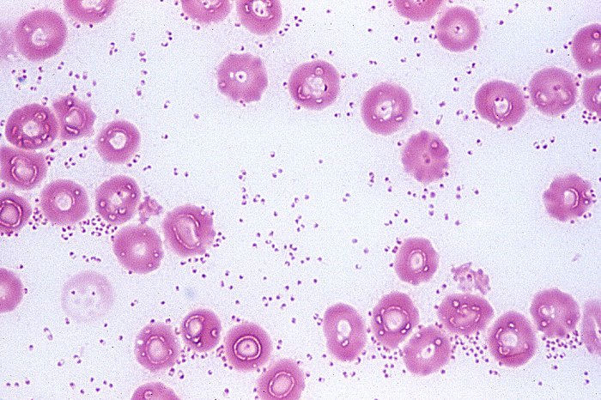
bipolarity
كل نقطتين من اللى فى الصورة دول عبارة عن بكتريا واحدة وليس 2 بكتريا لأن الصبغة بتصبغ قطبى البكتريا فقط.
Culture characteristics:
- Facultatively anaerobic and grow optimally at 37°C.
- Can grow on ordinary media but their growth is enhanced with addition of serum or blood.
- On blood agar, the colonies are round, greyish, shinny, mucoid, haemolytic and odourless in case of M. haemolytica while non haemolytic and has characteristic sweetish odour in case of P. multocida
- On MacConkey agar, M. haemolytica grow as pin point red colonies while P. multocida don't grow on MacConkey.

Biochemical characteristics:
- Oxidase positive and reduces nitrate to nitrite.
- Ferments glucose with acid production.

Laboratory diagnosis:
1) Sampling: According to the infection
2) Microscopical examination.
3) Isolation and identification.
4) PCR.
Genus Heamophilus

Morphology:

Gram-negative coccobacilli, non-motile, non-spore forming and non-capsulated except H. influenza encapsulated with polysaccharide capsule.
الـ capsule دى مهمة فى التعرف سريعا على الـ H. influenza فى تشخيص حالات الـ meningitis فى الأطفال (حالات حرجة تحتاج الى تشخيص سريع).

Culture characteristics:
- Facultatively anaerobic but grow better in presence of 5-10% CO₂.
- Fastidious bacteria, requires blood products for growth
ومن هنا سميت بالـ Heamophilus التى تعنى Blood loving bacteria
طيب ما هى هذه الـ blood products أو Bacterial Vitamins
a) Factor X (hematin); it present in blood outside RBCs.
b) Factor V (NAD nicotineamide adenine dinucleotide); it present inside RBCs,
لذا عشان تتوفر للبكتريا فى الميديا هعمل إحدى طريقتين
1) أزرع على ميديا بتحتوى على lysed RBCs زى chocolate agar أو Fildes agar Levinthal’s agarأو
2) أزرع على Blood agar مزروع عليها فى نفس الوقت بكتريا بتعمل تكسير لكرات الدم الحمراء زى الـ Staph aureus (haemolytic bacteria as Staph. aureus) و الطريقة دى بتسمى
(Staph. streak technique)
ولما عملوا الطريقة دى وجدوا أن نمو الـ Heamophilus بيكون أفضل كل ما قربنا من الستاف المزروعة (لو بيصنا فى الصورة هنلاقى الكولنيز بتاعة ال Heamophilusبتكون أكبر كلما إقتربنا من الكولينز بتاعة الـ Staph ) والظاهرة دى بيسموها Satellitism phenomenon ودا طبعنا لانه كل ما قربنا من الـ Staph كل ما توفر Heamophilus الـ Factor V
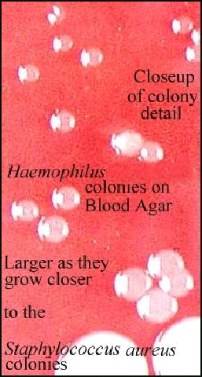
- On chocolate agar, Heamophilus produces grayish, translucent smooth - low convex colonies.

Haemophilus species and diseases caused by them:

a) H. paragallinarum causes infectious coryza in chicken and turkey. It is characterized by inflammation of the upper respiratory tract, especially para nasal sinuses (Facial swelling).
b) H. influenza causes meningitis and pneumonia in human.
c) H. somnus causes Enzootic calf pneumonia, septicemia, meningoencephalitis, abortion, bronchopneumonia and mastitis in cattle.

Laboratory diagnosis of infectious coryza:
1) Sampling
2) Microscopic examination
3) Isolation and identification
4) Identification of the isolated colonies using (Staph. streak technique).
5) Serology tests as HI, IF.
6) A PCR.

Genus Actinobacillus
Morphology:

Gram-negative coccobacilli, sometimes occurring in long chains or unpointed filaments, non-motile and non-spore forming.

Diseases caused by members of Genus Actinobacillus:

Actinobacillus lignieresii causes wooden tongue/ actinobacillosis in cattle (mainly) and Sheep.
This bacterium is a part of the normal bacterial flora of the upper digestive tract. It invades mouth cavity tissue through breaks, abrasions or wounds.

In this disease, tongue becoming hard, swollen, protrudes between the lips and painful. As the disease becomes chronic, the tongue becomes hard, shrunken and immobile (wooden tongue). The regional lymph nodes become swelled and may ulcerated discharging milky white or slightly green pus containing the characteristic grayish granules (تحتوى على البكتريا). These abscesses may present internally in the lung and may be confused with bovine tuberculosis.

Differential diagnosis of this disease from the following:
- Lumpy jaw caused by Actiommyces; Lumpy jaw affects the bones.
- Presence of foreign bodies in the mouth; examination reveals foreign bodies.
- Tuberculosis of internal organs.

Genus Campylobacter

They are found in the reproductive and alimentary tracts of man & animals.

Campylobacter species and diseases caused by them:
a) C. fetus var (= subspecies) fetus causes Epizootic abortion in sheep and goat near the end of gestation.
b) C. fetus var (subspecies) venerealis causes endometritis and salpingitis (i.e. infertility) in cows.
هذا المرض يسمى Bovine genital campylobacteriosis وغالبا ما يحدث بدخول طلوقة جديدة الى المزرعة لان
This species localized in the prepuce of bull and infects cows through coitus.
c) C. coli causes enterocolotis in pigs.
d) C. jejuni causes enterohepatitis in chicken and entritis in dogs and human.

- H. pylori (Helicobacter pylori أو جرثومة المعدة) is found in the stomach of 30 to 50% of adults in the developed countries and in up to 90% of adults in the developing countries. It is the most common cause of gastritis, gastric and duodenal ulcers and may cause gastric adenocarcinoma.
واللي هيشتغل فى معمل تحاليل هتجيلة حالات كتير لتشخيصها عن طريق إختبار
Detection of H. pylori Ag in stool
- V. cholerae (Vibrio cholerae) causes cholera.
- V. anguillarum causes Red Pest of Eel.
- V. parahaemolyticus cause food poisoning following ingestion of raw or inadequately cooked seafood.

Morphology:
        - Short Gram-negative curved rods.
ولذلك سميت Campylobacter وزمان كان أسمها Vibrio
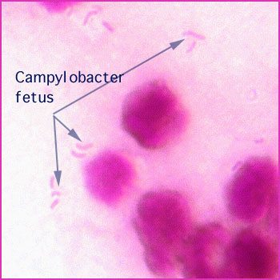
        - Highly motile with single polar flagellum with characteristic cork screw like motion(حركة زى المسمار القلوظ) under dark field or phase contrast microscope.
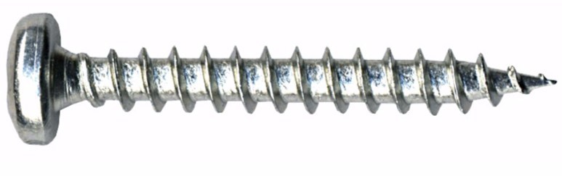
وغالبا مش بيحدث انفصال للخلايا البكترية أثناء الانقسام فبيظل كل خليتين متصلتين فى نهايتهما فتظهر وهما بيتحركوا تحت الميكروسكوب كجناحين طائر النورس
        - The two daughter cells often remain attached at their ends and appear as wings of the gull.
Culture characteristics:
- For proper isolation, the samples should be cultured immediately or held in transport media as Clark's media where Campylobacter species are sensitive. Also, it is preferred to filter the sample before the inoculation to exclude other bacteria.
- Isolated on enriched media as skirrow's media and incubated in an atmosphere of 10-20% CO₂ and 5% or less O₂ (microaerphilic condition).
- On skirrow's media, produce small grayish colonies.

Biochemical characteristics:
- Catalase, oxidase & hippurate hydrolysis positive.

